**Setting up Raspberry Pi**

**Step 1 : Prepare your SD Card**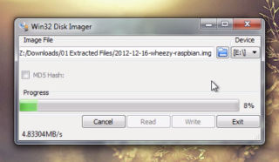

1. Download Win32DiskImager and unzip the application (.exe file) inside. (<http://sourceforge.net/projects/win32diskimager/>)
2. Insert your SD card into your Windows PC using a card reader.
3. Open Win32DiskImager.exe, the application you just downloaded, by double-clicking on it. If you're running Windows 7 or 8, right click on it and choose "Run as Administrator" instead.
4. In the image file section of the application, click the little folder icon and choose the Raspbian .img file you just downloaded.
5. Click the Write button and wait for Win32DiskImager to write image file to the sd card. When it finishes, you can safely eject your SD card and insert it into your Raspberry Pi.

**Step 2 : Assigning IP address**

1. Connect the pi with your laptop using Ethernet cable. Now, on your pc open command prompt by typing ‘cmd’ in start menu. Write ‘ipconfig’ to show the list of connections. Note down the ipv4 address under Ethernet. It should be something like this 192.169.254.12
2. Remove the power cable. Remove SD card and insert in your laptop. Open the drive of your SD card. Find and open ‘cmdline.txt’ using notepad++.
3. At the end of the first line type ‘ip=192.169.254.X’ where x is any number from 0-255 and others are the same as the ipv4 address you noted.
4. This one line of text should be followed by one blank line. Make sure there are only 2 lines. This is an important step. If your pi doesn’t get connected in next steps for some reason check this step first. Save the ‘cmdline.txt’ file. Remove your SD card and insert it in pi.

**Step 3 : Configuring putty**

1. Connect pi to your laptop. Start an application putty. It can be downloaded from here.

(<http://www.chiark.greenend.org.uk/~sgtatham/putty/download.html>)

1. In the host name, write the ip address you assigned to pi. Don’t change port number.
2. Click ‘Open’. A terminal will open and a message will be displayed. Click on ‘Yes’. If there is an error message ‘Connection Refused’, wait for 1 minute more and try again. If there is an error message ‘No route to host’, the problem is with your ip address. Check it again.
3. After connecting to the terminal, it will ask for login name. Enter ‘pi’ as login id and ‘raspberry’ as your password. This is set by default.
4. You will get access to your pi.

**Step 4 : Accessing the GUI of pi**

1. Download ‘Xming’ from here. (<http://sourceforge.net/projects/xming/>)
2. Run the application to start X server.
3. In putty on the column on left side go to ssh->x11. Check on ‘Enable x11 forwarding’.
4. Go back to session. Open the connection.
5. Type ‘startlxde’. You should see the desktop environment opening.
6. To exit from your GUI, in putty terminal press ‘ctrl+c’.

**Step 5 : Configuring internet**

1. Open the terminal through putty. Type ‘sudo nano /etc/network/interfaces’. A file opening like this will open.

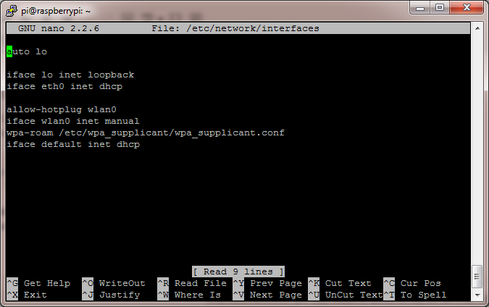

1. Change the file to this.

*auto lo*

*iface lo inet loopback*

*iface eth0 inet dhcp*

*allow-hotplug wlan0*

*auto wlan0*

*iface wlan0 inet dhcp*

*wpa-ssid "Your Network SSID"*

*wpa-psk "Your Password"*

1. Enter your wifi name and password. It is case sensitive.
2. Save the file using ‘ctrl+x’ and ‘Y’.
3. Use ‘sudo reboot’ to restart the pi.
4. Type ‘sudo ifup wlan0’. Use ‘Ping’ to check the connection.
5. For shutting the wifi adapter down ‘sudo ifdown wlan0’.